READING PASSAGE 1

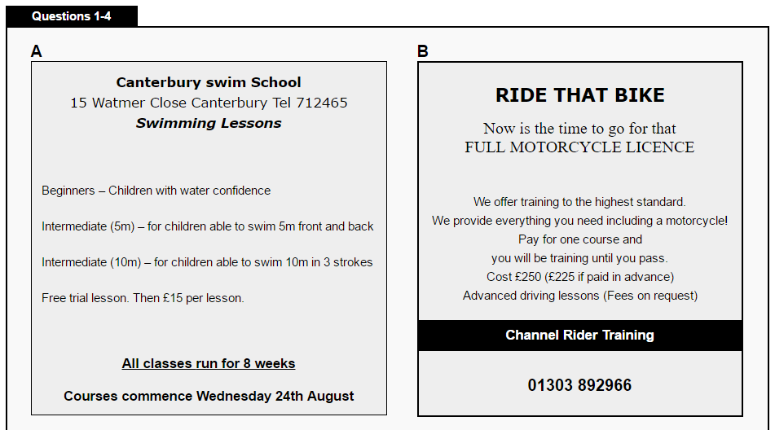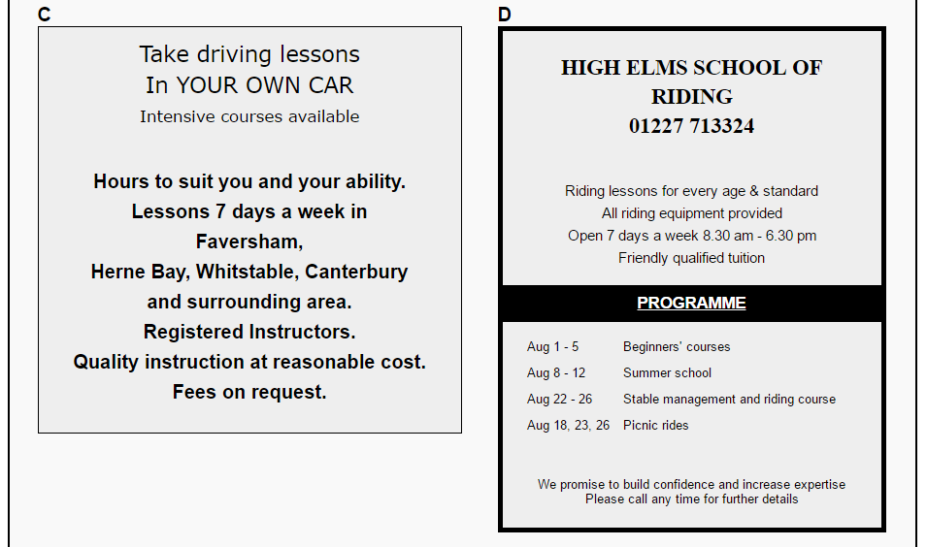

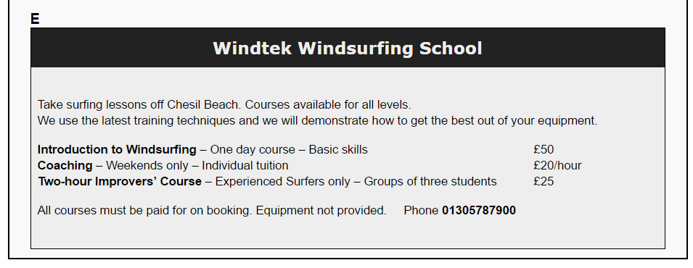

**Questions 1-4**

Look at the five advertisements**, A-E,**

Answer the questions below by writing the correct letters**, A-E,** in boxes 1-4 on your answer sheet.

**1)** Which TWO advertisements mention entry requirements?

**2)** Which TWO advertisements say what you will have achieved by completing the course?

**3)** Which TWO advertisements mention being run by professionally trained teachers?

**4)** Which advertisement indicates that it doesn't matter how old you are?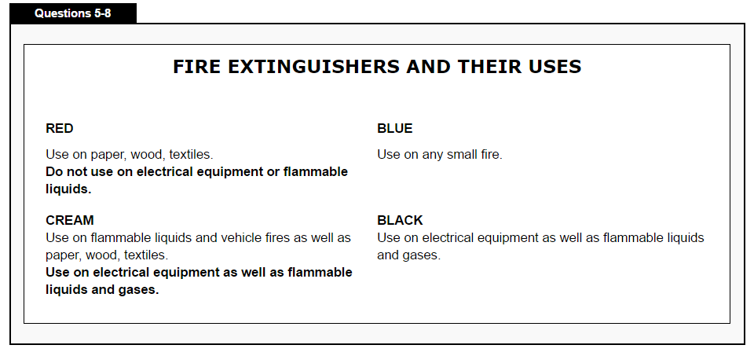

**Classify the types of extinguishers which should be used on fires in the following situations.**  
Answer the questions below by writing the correct letters, **A-E**, in boxes 1-4 on your answer sheet.

|  |  |
| --- | --- |
| Write | **A**    if only cream or black should be used |
|  | **B**    if only cream or red should be used |
|  | **C**    if only blue or black should be used |
|  | **D**    if only cream, red or blue should be used |
|  | **E**    if only red or black should be used |

Write the correct letter, A-E, in boxes 5-8 on your answer sheet.

**NOTE You may use any letter more than once.**

**5)** a plug in its socket

**6)** a large industrial oil spill

**7)** a frying pan of cooking oil on an electric cooker

**8)** the edge of a curtain

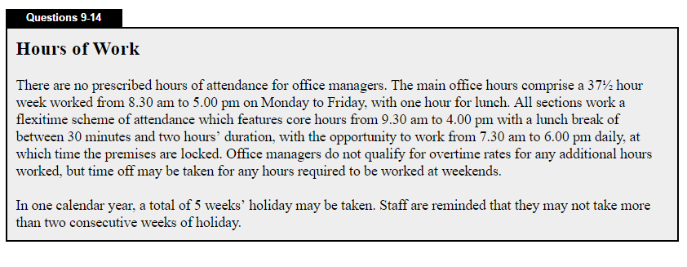

**Questions 9-14**

Do the following statements agree with the information given in Reading Passage 1.

In boxes **9-14** on your answer sheet, write

**TRUE if the statement is true according to the passage**

**FALSE if the statement is false according to the passage**

**NOT GIVEN if the information is not given in the passage**

**9)** Office managers must work from 8.30 am to 5 pm with one hour for lunch.

**10)** All employees must work between 9.30 am and 4 pm, except for lunch time.

**11)** The building shuts at 5 pm.

**12)** All employees who are not office managers are paid overtime if they work later than 5 pm.

**13)** Office managers are paid extra money for working at weekends.

**14)** It is possible to have a two-week holiday in summer and a two-week holiday in winter.

**READING PASSAGE 2**

**THE END OF THE SILVER SCREEN**

Cinema technology has remained much the same for a century, so when will it go digital? Kevin Hilton views the projections.

**A**. Cinema is full of contradictions. It is high-tech and old-fashioned at the same time. Today's films are full of digital sound and computer-generated special effects. Yet they are still stored on celluloid film, the basis of which is more than 100 years old. They are also displayed with projectors and screens that seem to belong to our great grandparents' generation.

**B.** Now that we are in the second century of cinema, there are moves to bring the medium right up to date. This will involve revolutionizing not just how films are made but also how they are distributed and presented. The aim is not only to produce and prepare films digitally, but to be able to send them to movie theatres by digital, electronic means. High-resolution digital projectors would then show the film. Supporters say this will make considerable savings at all stages of this chain, particularly for distribution.

**C.** With such a major technological revolution on the horizon, it seems strange that the industry is still not sure what to call itself. This may appear a minor point, but the choices, 'digital' cinema and 'electronic' cinema (e-cinema), suggest different approaches to, and aspects of, the business. Digital cinema refers to the physical capture of images; e-cinema covers the whole chain, from production through post-production (editing, addition of special effects and construction of soundtrack) to distribution and projection.

**D**. And what about the effects of the new medium? The main selling point of digital cinema is the high resolution and sharpness of the final image. But those who support the old-fashioned approach to film point to the celluloid medium's quality of warmth. A recurring criticism of video is that it may be too good: uncomfortably real, rather like looking through an open window. In 1989, the director of the first full-length American digital high-definition movie admitted that the picture had a 'stark, strange reality to it'.

**E**. Even the money-saving aspect of e-cinema is doubted. One expert says that existing cinemas will have to show the new material and not all of them will readily or rapidly furnish themselves with the right equipment. 'E-cinema is seen as a way of saving money, because print costs a lot,' he says. Tut for that to work, cinemas have to be showing the films because cinemas are the engine that drives the film industry.'

**F**. This view has prompted some pro-digital entrepreneurs to take a slightly different approach. HD Thames is looking at reinventing the existing cinema market, moving towards e-theatre, which would use digital video and projection to present plays, musicals and some sporting events to the public. This is not that different from the large-screen TV system that was set up in New York in 1930, and John Logie Baird's experiments with TV in the late 1920s and early 30s.

**Questions 15-20**

The Reading Passage has six paragraphs A–F.

Choose the correct heading for each paragraph from the list of headings below.

**List of Headings**

**i** Indecision about a name

**ii** Current problems with distribution

**iii** Uncertainty about financial advantages

**iv** The contrasts of cinema today

**v** The history of cinema

**vi** Integrating other events into cinema

**vii** The plans for the future of films

**viii** An unexpected advantage

**ix** Too true to life?

**NOTE: YOU MAY NOT USE ALL YOUR OPTIONS**

**15)** Paragraph A

**16)** Paragraph B

**17)** Paragraph C

**18)** Paragraph D

**19)** Paragraph E

**20)** Paragraph F

**Questions 21-26**

Complete the summary below.

Choose **NO MORE THAN THREE WORDS** for each answer.

Write your answers in boxes **21-26** on your answer sheet.

There are big changes ahead for cinema if digital production takes place and the industry no longer uses (**21**) ............. and gets rid of the old-fashioned (**22**) ............., (**23**)………….. and used to show movies. The main advantage is likely to be that the final image will be clearer. However, some people argue that the digital picture will lack (**24**) .............. In addition, digital production will only reduce costs if cinemas are willing to buy new (**25**) .............. As a result, experiments with what is called (**26**) '.............' may mark a change in the whole entertainment industry.

**READING PASSAGE 3**

**WHAT TO DO IN A FIRE**

Fire drills are a big part of being safe in school: They prepare you for what you need to do in case of a fire. But what if there was a fire where you live? **Would you know what to do?** Talking about fires can be scary because no one likes to think about people getting hurt or their things getting burned. But you can feel less worried if you are prepared.

It's a good idea for families to talk about what they would do to escape a fire. Different families will have different strategies. Some kids live in one-story houses and other kids live in tall buildings. You'll want to talk about escape plans and escape routes, so let's start there.

**Know Your Way Out**

An escape plan can help every member of a family get out of a burning house. The idea is to get outside **quickly and safely**. Smoke from a fire can make it hard to see where things are, so it's important to learn and remember the different ways out of your home. How many exits are there? How do you get to them from your room? It's a good idea to have your family draw a map of the escape plan.

It's possible one way out could be blocked by fire or smoke, so you'll want to know where other ones are. And if you live in an apartment building, you'll want to know the best way to the stairwell or other emergency exits.

**Safety Steps**

If you're in a room with the door closed when the fire breaks out, you need to take a few extra steps:

* Check to see if there's heat or smoke coming in the cracks around the door. (You're checking to see if there's fire on the other side.)
* If you see smoke coming under the door — **don't open the door!**
* If you don't see smoke — touch the door. If the door is hot or very warm — **don't open the door!**
* If you don't see smoke — and the door is not hot — then use your fingers to lightly touch the doorknob. **If the doorknob is hot or very warm — don't open the door!**

If the doorknob feels cool, and you can't see any smoke around the door, you can open the door very carefully and slowly. When you open the door, if you feel a burst of heat or smoke pours into the room, quickly shut the door and make sure it is really closed. If there's no smoke or heat when you open the door, **go toward your escape route exit**.

**Questions 27-33**

Complete the sentences below.

Choose **NO MORE THAN TWO WORDS** from the text for each answer.

Write your answers in boxes **27-33**on your answer sheet.

**27**. While some might live in a tall buildings, others might live in a ……………..

**28**. Important thing is to talk with your kids about escape ………… and (**29**)……….

**30**. Making a ………. is a good idea, it can help you escape.

**31**. If you live in an apartment, you have to know the way to the staircase or other ………

**32**. You can only open the door if the ……….. is not hot and you can’t see smoke around the door.

**33**. You should immediately close the door, if smoke ……… into the room

**Questions 34**–**38**

Do the following statements agree with the information given in Reading Section 3?

In boxes **35–39** on your answer sheet, write

**TRUE if the statement agrees with the information**

**FALSE if the statement contradicts the information**

**NOT GIVEN if there is no information on this**

**34**. It is important to have a strategy before escaping the fire.

**35**. You should mark different ways out of your home on the map.

**36**. If you’re stuck in a room, and see smoke coming from the other room, you should open the door and run to the exit.

**37**. Hot door means you shouldn’t open it to escape.

**38**. If you open the door and everything seems fine, go straight to the exit.

**39**. If the doorknob feels cool and there is no sign of smoke, proceed with caution.

Question **40**

Choose the correct letter, A, B, C or D.

Write the correct letter in box 40 on your answer sheet.

**40**. This article is mainly aimed at helping:

A Children

B Children and their parents

C Only parents

D Teachers at schools